**Azure Provider**

* <https://registry.terraform.io/providers/hashicorp/azurerm/latest/docs> for the provider documentation
* To install azure cli <https://learn.microsoft.com/en-us/cli/azure/install-azure-cli-linux?pivots=apt#option-1-install-with-one-command> To authenticate azure cli

az login

az group list

**Providers and resources**

* In terraform to create any resource we need to configure provdier
* Every provider has a specific structure

provider "<name>" {

<ARGUMENT-1> = <VALUE-1>

..

..

..

<ARGUMENT-N> = <VALUE-N>

}

* AWS Provider argument reference <https://registry.terraform.io/providers/hashicorp/aws/latest/docs#argument-reference>
* Azure Provider argument reference <https://registry.terraform.io/providers/hashicorp/azurerm/latest/docs#argument-reference>
* Resource: The syntax or structure of resource in terraform template is

resource <type of resource> <name> {

<ARGUMENT-1> = <VALUE-1>

..

..

..

<ARGUMENT-N> = <VALUE-N>

}

* the type of resource will be in the form of <provider>_<resource_type>

**Manual Steps of VPC Creation**

* Steps: Lets create a simple vpc  
  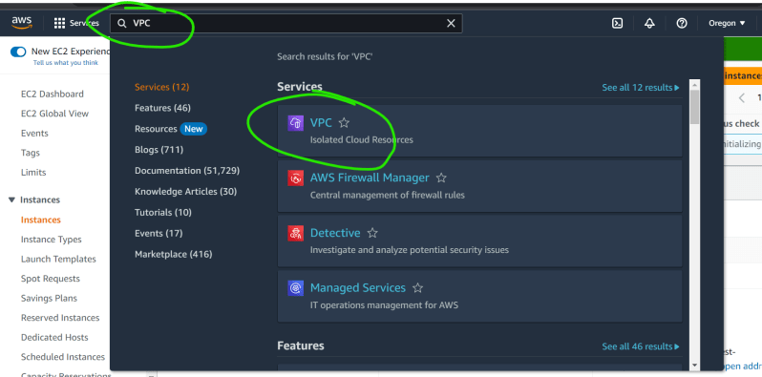  
  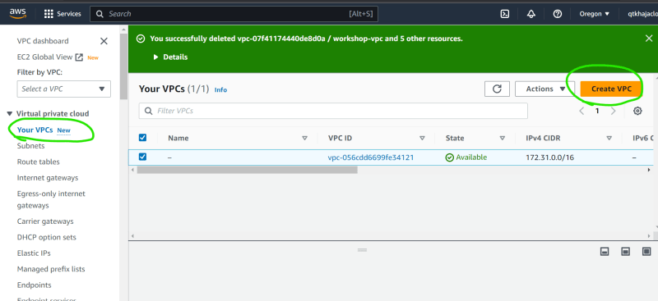  
  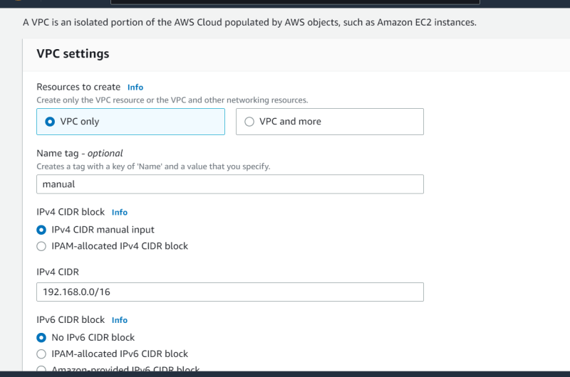  
  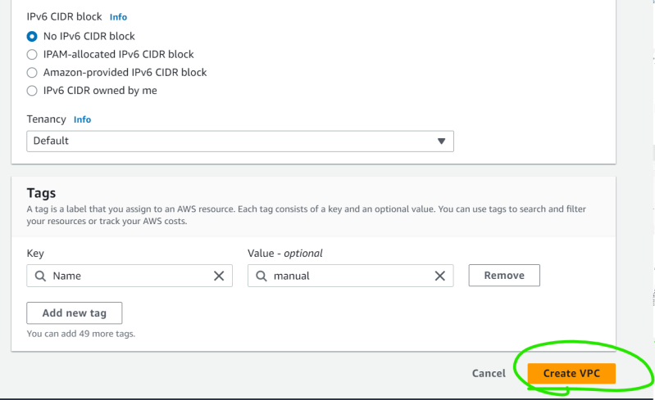  
  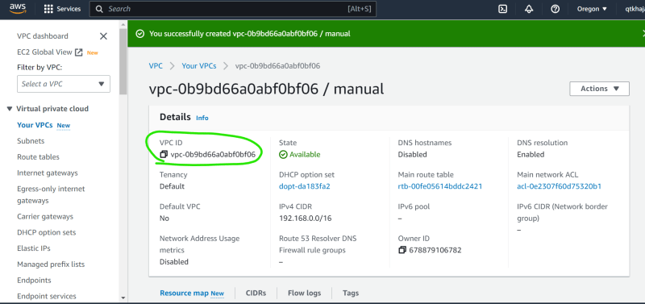  
  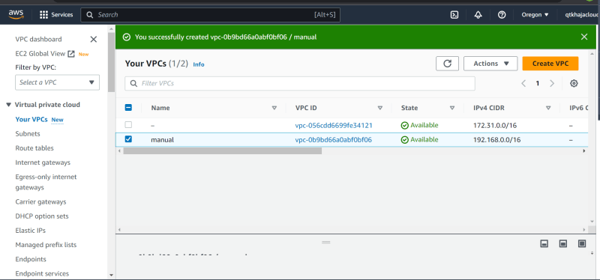
* Lets search for resource which lead to [Refer Here](https://registry.terraform.io/providers/hashicorp/aws/latest/docs/resources/vpc)  
  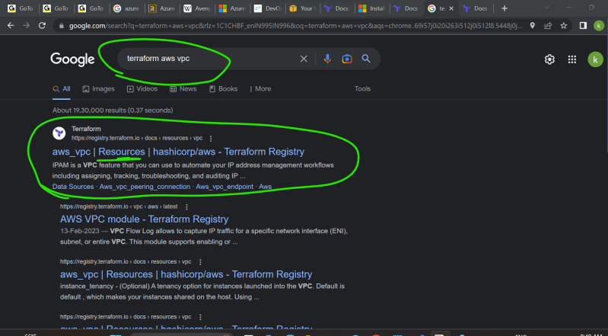
* Now look at arguments <https://registry.terraform.io/providers/hashicorp/aws/latest/docs/resources/vpc#argument-reference>
* Create the template as shown in this changeset

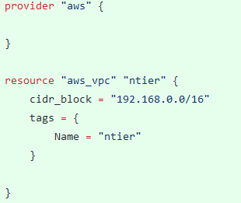

* Now validate and apply  
  